
CC 1000

 | 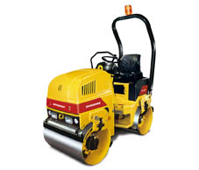
  Capacity
  Asphalt up to |  | 455 m2/h
  Soil up to |  | 130 m3/h
  Specifications
  Operating mass (incl. ROPS) |  | 1650 kg
  Front module mass |  | 810 kg
  Rear module mass |  | 840 kg
  Max. operating mass |  | 1730 kg
  Static linear load std/max front/rear |  | 8,1/8,4 kg/cm
  Centrifugal force |  | 17 kN
  Propulsion |  | Both drums
  Water tank |  | 105 litres
  Frequency/Amplitude |  | 70 Hz/0,35 mm
  Speed |  | 0-9 km/h
  Curb clearance |  | 465 mm
  Engine
  Rated power, SAE J1995,  at 2600 rpm |  | 17 kW
  Model |  | Perkins 403C-11
  Dimensions
  Drum diameter |  | 584 mm
  Length, w/w.o ROPS |  | 2095/2040 mm
  Height, w/w.o ROPS |  | 2300/1520 mm
  Drum width |  | 1000 mm
  Drum shell thickness |  | 13 mm
  Width, w/w.o ROPS |  | 1070/1070 mm

v

