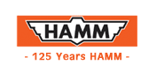

PRODUCTS / ASPHALT COMPACTION

Small Articulated Rollers
Designed specifically for asphalt compaction
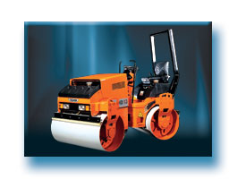

Small Articulated Rollers
 | Type |  | Weight (kg) |  | Working width
  HD 10
  2,530
  1,000 mm

Articulated Rollers offer features
that set HAMM apart from all other rollers:
- Hydrostatic drive, infinitely variable
- Hydrostatic articulation
- Automatic vibration system
- Crab steering up to 50 mm
- 2 multifunctional drive levers
- Suspended driver stand
- 3 Braking systems
- Excellent manoeuvrability
- Engine Deutz/F2L 1011F Power 20 Kw.

Options
ส่วนบนของฟอร์ม

ส่วนล่างของฟอร์ม
to the top | << back | order info material | home |
Copyright © 2003 HAMM AG. All rights reserved.
No part of this content may be copied with out any permission.

